**The Planet Explorer**

Game Design Document

**Logline**

Help two aliens reach their planet since they have lost their way. They need to dodge giant rocks, beat their enemies, and collect energy to survive. Oh, but just remember, the aliens are connected and the movement of one alien affects the other.

**Theme |** Space **Genre** | Multiplayer Space Exploration, Strategy

**Twist |** The two players are interdependent

**Links**

Github Page WebGL Build: <https://riddhihakani.github.io/PlanetExplorerFinalBuild/>

Github Code: <https://github.com/riddhihakani/PlanetExplorer>

Youtube Link: <https://youtu.be/exO_pvww5Jc>

**Individual Contribution**

**Riddhi Hakani:** Game Logic(Alien Connection, Planet Interaction, Enemy Alien), UI, GDD

**Xin li:** Game Logic(Alien Size Modification, Asteroid, Food), UI, GDD

**Prototype Description**

The goal is to reach the destination planet before the aliens die. The aliens have to explore through space and save themselves by not running into planets, the enemy, or asteroids. If encountered by these objects, the size of the alien decreases and if any one alien reaches the minimum value, the alien dies. To combat this, the alien needs to collect food and booster, so size increases. The effect of each element on the alien is listed below.

| **Element** | **Control/Effect on Player** |
| --- | --- |
|  | Pink Alien  Controls - Up and Down Arrow Key |
|  | Green Alien  Controls - Left and Right Arrow Key |
|  | Food for Pink and Green Alien Respectively  Increases the size of the alien if it is less than maximum size. |
|  | Power Booster  Increases the size of the alien if it is less than maximum size.  They wander in space. |
|  | Asteroid  Weakens the connection link(decreases width) between the aliens. If the connection link reaches a minimum value, the game is over. |
|  | Planets  Reduce the size of aliens if they enter the planet’s gravitational field. If size exceeds the minimum size, the game ends. They keep rotating automatically. |
|  | Enemy  Reduce the size of aliens if hit by the enemy’s venom. If size exceeds the minimum size, the game ends. They keep moving from left to right. |

**Game Sketch**

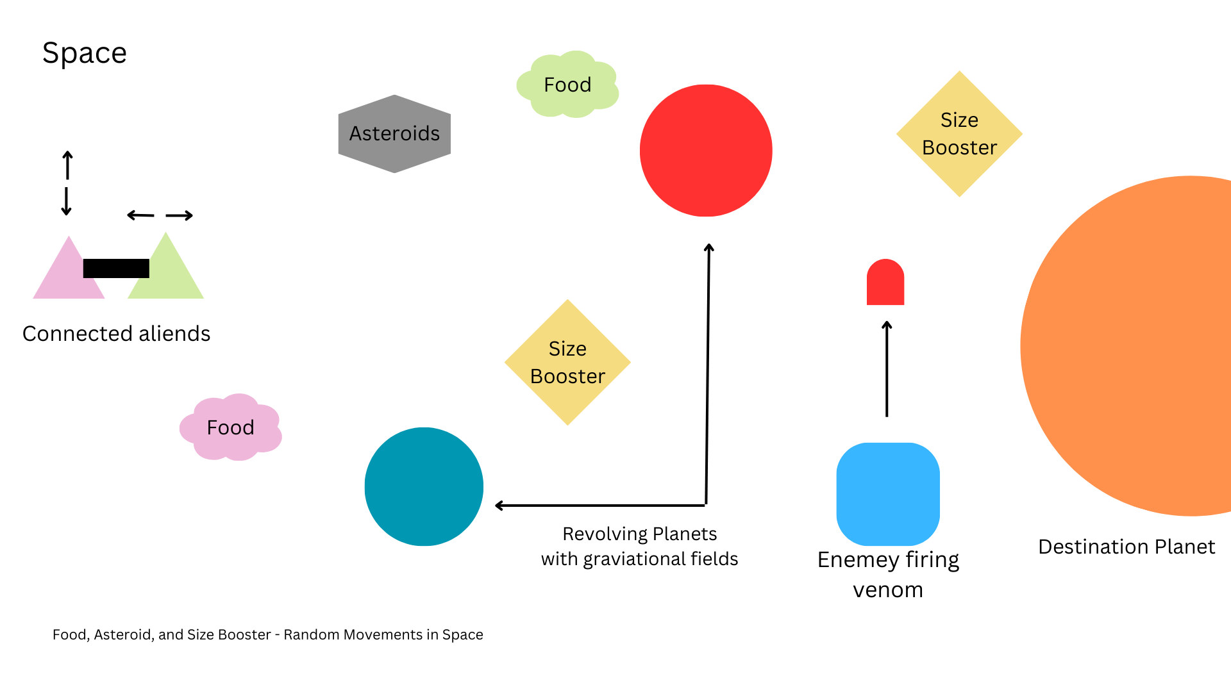

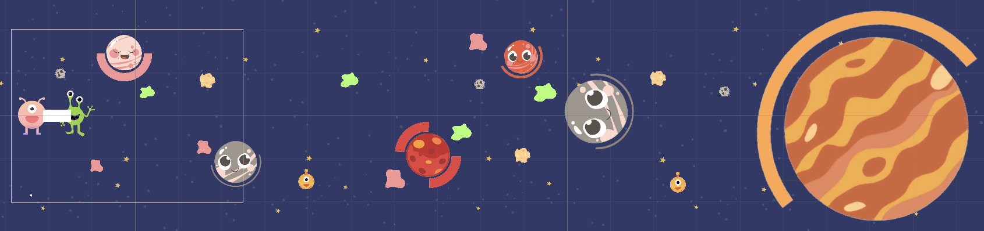

**Assets**

UI customized on Canva.

By,

Riddhi Hakani ([rhakani@usc.edu](mailto:rhakani@usc.edu))

Xin Li ([xli97011@usc.edu](mailto:xli97011@usc.edu))